VySkan
Product Name | 4G LTE Advanced Telematics Terminal
Product Model | VF50R

Versatility. Precision. Seamless Integration.

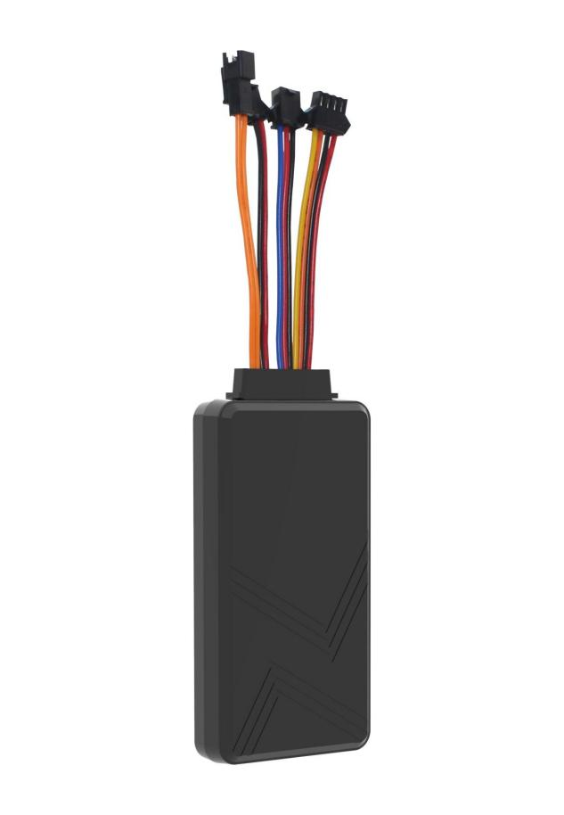

Engineered for complex fleet management and heavy-duty logistics, the VF50R is a highly expandable 4G LTE tracking terminal. It bridges the gap between precise GNSS tracking and deep vehicle telemetry by offering rich I/O interfaces, CAN bus data reading, and hassle-free software integration.

Core Value
- Ultimate I/O Expandability
Beyond simple tracking, the VF50R is equipped with RS232/RS485 and CAN bus interfaces. Easily integrate with external cameras, RFID readers, and extract rich OBD vehicle telemetry to build a customized, comprehensive IoT solution.
- Zero Data Loss Guarantee
Never lose a track. Built-in dynamic storage automatically logs telemetry data during cellular signal blind spots and seamlessly uploads it upon reconnection, ensuring 100% data integrity for your fleet's routes.
- Intelligent Power Management
Featuring a wide 9V-50V operating range and an ultra-low sleep current (5-15mA), it protects vehicle batteries while providing active defense through power-loss and geo-fencing alerts.

Target Applications
- Heavy-Duty Logistics & Freight (CAN bus/OBD tracking)
- Enterprise Fleet Management (Vehicle status monitoring)
- Public Transport & Passenger Vehicles (Camera & RFID integration)
- Construction & Industrial Equipment (Asset utilization)
- Technical Specifications
3.1 Cellular & GNSS
Category | Specification | Description
Cellular Module | Quectel EC20 | Industrial-grade 4G LTE communication module.
Network Bands | 4G LTE-FDD/TDD  3G WCDMA /  2G GSM | Broad coverage for global fleet operations with seamless fallback.
SIM Card | Standard SIM | Accessible slot for easy deployment.
GNSS Module | ZKMicro AT6558D (GPS+BDS) | High-performance dual-satellite tracking chip.
Positioning Accuracy | 5 - 10 meters | Pinpoint precision for real-time asset visibility.
Start Time | Cold: Avg 32s  Hot: Avg 1s | Rapid satellite acquisition supported by AGPS.

3.2 Power & Electrical

Category | Specification | Description
Operating Voltage | DC 9V - 50V | Wide voltage range compatible with light and heavy-duty vehicles.
Working Current | 30 - 60 mA @ 12V | Standard active tracking mode.
Sleep Current | 5 - 15 mA @ 12V | Ultra-low power consumption mode.
Backup Battery | 180 mAh / 3.7V (Optional) | Triggers main power-loss alarms for active defense.
3.3 Interfaces & Expandability
Category | Specification | Description
Digital Inputs | 2x High (ACC/Doors)  1x Low (SOS/Seatbelt) | Comprehensive monitoring of vehicle status.
Digital Outputs | 1x Low Output | Remote fuel/power cut-off or door lock control.
Serial Ports | 1x RS232 / RS485 | Integrates with external cameras and RFID readers.
Vehicle Bus | 1x CAN Bus | Reads deep automotive OBD diagnostic data.
Audio | 1x Mic Input | Supports parallel external microphones for voice monitoring.

3.4 Physical & Environmental
Category | Specification | Description
Dimensions | 87mm × 64mm × 26mm | Compact footprint for covert installation.
Weight | 140g | Robust yet lightweight design.
Housing Material | ABS Plastic | Industrial-grade durability.
Operating Temp. | -30℃ to 75℃ | Reliable operation in extreme climates.
Mounting | Magnetic Support | Optional strong magnetic mount for versatile deployment.

Built for Rapid Integration & Telemetry
We know hardware is only half the solution. The VF50R is designed to drastically reduce your Time-to-Market (TTM) and development costs.
- Standard Protocols
Natively supports TCP/UDP and the industry-standard GT06 protocol.
- Supported Platforms
Seamlessly integrates with industry-leading tracking software including Wialon, Traccar, and enterprise custom dashboards without reverse engineering.
- CAN Bus Ready
Comprehensive Open API documentation helps your IT team effortlessly parse not just GPS coordinates, but deep OBD telemetry data, achieving live dashboard connectivity in under 48 hours.
- A personalized service prepared for you
- 1×VF50R Sample Device (Pre-configured)
- Full API & Protocol Documentation
- 1-on-1 Technical Support from our Field Engineers
- Contact us
Website：https://vyskan.com/
Email: marketing@vyskan.com

